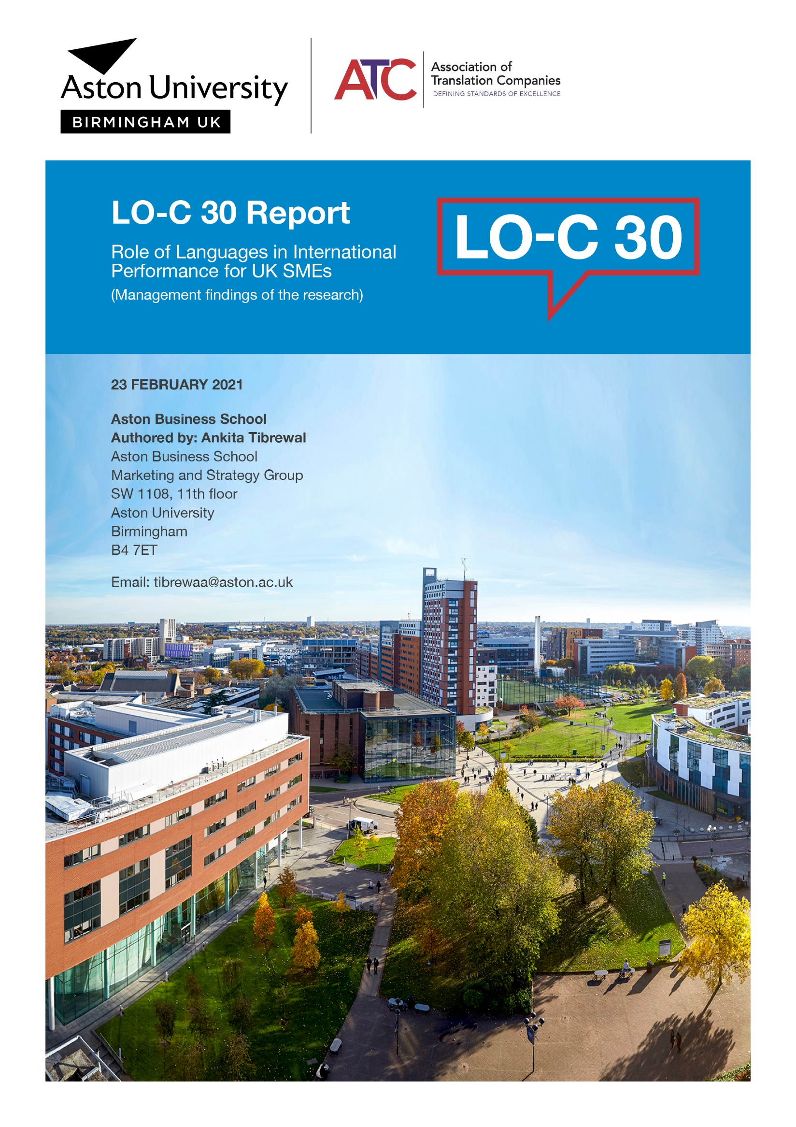

Supervisors
Prof Ad de Jong, PhD
Department of Marketing
Copenhagen Business school
Solbjerg Plads 3, 2000 Frederiksberg F
Denmark

Dr Geoff Parkes
Senior Lecturer, Marketing and Strategy group
Aston Business School
Aston University
Birmingham
B4 7ET

Disclaimer: This document reports the findings of the study carried for the purpose of fulfilling the requirements of Doctor of Philosophy degree at Aston Business School. The studentship was granted for the study by Aston Business School in collaboration with Association of Translation Companies (ATC) for the period of three years. The content of this report does not constitute business advice and should not be acted upon in isolation. The authors, Aston Business School and Aston University, accept no liability for any third party acting upon the findings set out in this report. The report remains the intellectual property of the authors and no part of this report may be reproduced or quoted without appropriate references or prior permission being granted by the authors.

Table of Contents
Executive Summary 4
Performance Indicators 5
Relevance of Key Drivers 6
Introduction: Research Rationale, Objectives and Methodology 6
Research Strategy and Source of Data 8
Research Schedule 9
Data Cleaning and Data Analysis 9
Research Findings 9
Profile of the SMEs 10
Main Findings of the Report 13
Main Findings (1): Descriptive Statistics – Means, Standard Deviations and Correlations 14
Correlations Analysis 14
Main Findings (2): Impact of LO-C on Performance Indicators 15
Main Findings (3): Key Drivers of LO-C 18
Conclusion 20
Glossary of Terms 21
Key Variables in Model 21
Statistical Tools 21
Control Variables 22
Appendix 22

Executive Summary
The study is a unique, comprehensive country-level empirical study that examines the organisational-level language capacity (LO-C) and its drivers. LO-C refers to both motivation and preparedness (attitude) towards developing language-related capabilities as well as (behaviour) actual utilisation of the language capabilities within the organisation. This study identifies the impact of LO-C on UK small and medium-sized enterprises’ (SMEs) international performance indicators such as Export Orientation, Export Sales, Export Profit and Export Sales Growth. In this study SMEs are defined as firms with fewer than 250 employees (European Commission, 2008) and UK SMEs which were independent business units, i.e. which were not part of any large companies/multinational corporations (MNCs) at the time of inclusion. The gathering of self-reported primary data was facilitated by a web-based questionnaire survey sent to SMEs across the UK. To facilitate the questionnaire and identification of variables, the study also involved a preliminary study which consisted of semi-structured interviews with eight (8) key decision makers within SMEs, CEOs and managing directors of SMEs in the Midlands. Data from 415 completed surveys was obtained from SMEs, ranging in size from fewer than 10 employees to 250 employees, across different sectors (manufacturing (28%), information technology (14%), financial services (8%), automotive (4%), retail (25%) and other (21%)).

“SMEs embracing language capabilities are 30% more successful in exporting than those which do not”

In fact, the study not only tries to understand the impact of language capacity (LO-C)¹ on organisation export performance, but it also identifies key drivers that facilitate LO-C within an SME. The key drivers identified are Linguistic Competencies, Cultural Intelligence, Willingness to Invest (in translation services for example) and Training for Languages and Technological Awareness and its relative importance on LO-C. The research identifies Training and Willingness to Invest as the two most important drivers which facilitate LO-C within the organisation, while language capabilities and/or cultural awareness is necessary for LO-C. Furthermore, LO-C has a direct and positive relationship with Export Orientation, Value-based Selling, Export Sales and Export Sales Growth. We also identify size, industry/sector, age of the firm (in years), exporting experience and number of countries exporting markets as control variables.

Performance Indicators
Our subjective performance indicators such as Export Orientation and Value-based Selling and Co-creation in International Markets (VBSCC) are highly correlated with Export Sales, Export Profit and Export Sales Growth, and similarly the former are highly correlated with language capacity (LO-C). In fact, a deeper look at the data (regression analysis) suggested that LO-C has significant impact on not only Export Orientation and Value-based Selling but also Export Sales, Export Profit and Export Sales Growth. For our sample data of 415 responses, the regression coefficient, which is a numerical value of predictor variable and, in our case, language capacity (LO-C), is 0.594 for Export Orientation and 0.585 for Value-based Selling. Furthermore, the regression coefficient of language capacity (LO-C) is 0.296 for Export Sales, and 0.346 and 0.328 for Export Profit and Export Sales Growth respectively. The regression coefficient represents the amount of change in the outcome (predicted) variable for a one-unit change in independent (predictor) variable. In short, LO-C has a consequential positive impact on Export Orientation, Value-based Selling, Export Sales, Export Sales Growth and Export Profit, and clearly indicates that SMEs embracing language capabilities are 30% more successful in exporting than those which do not.

Relevance of Key Drivers
When identifying the role of language capacity (LO-C) in impacting export performance indicators, it is paramount to understand what language capacity comprises or, in other words, the key factors that are important for LO-C to exist within an SME. These factors are defined as key drivers. Through a rigorous process of literature review, data collection and analysis, five (5) key drivers have been identified, namely Linguistic Competencies, Cultural Intelligence, Willingness to Invest and Training for Languages and Technological Awareness.

Multiple regression analysis further helps us understand the relative importance of each of these drivers for LO-C. With the dataset of 415 responses, the regression coefficients are as follows: Linguistic Competencies has 0.210, Cultural Intelligence 0.227, Willingness to Invest 0.275, Training 0.349 and Technological Awareness 0.065, which indicates the relative importance of each driver for language capacity (LO-C).

Introduction: Research Rationale, Objectives and Methodology

Small and medium-sized enterprises (SMEs) play a crucial role in the economy. Research shows that they represent private sector businesses and are integral to job creation (almost 60%). At the start of 2020, there were 5.94 million small businesses (with 0 to 49 employees), 99.3% of all businesses. SMEs account for 99.9% of the business population (6.0 million businesses), three fifths of employment and around half of turnover in the UK private sector. Total employment in SMEs was 16.8 million (61% of the total), while turnover was estimated at £2.3 trillion (52%). Employment in small businesses (with 0 to 49 employees) was 13.3 million (48% of the total), with a turnover of £1.6 trillion (36%) (BIS, 2020).

Another study by the Centre for Economics and Business Research (CEBR) indicates that SMEs’ contribution to the UK economy was at £202 billion in 2016, a figure which is predicted to increase to £241 billion by 2025, a 19% increase over a 10-year period. This clearly demonstrates the vital contribution of SMEs to the UK economy. Research also suggests that around 75–80% of SMEs in UK close within 10 years (Wright et.al, 2015) of commencement due to lack of growth. One way to generate growth is to export products and/or services to international markets. Over the last 30 years, academic studies have identified the strong link between exports and growth in the UK. Internationalisation is becoming critically important for business survival and growth (Lu & Beamish, 2001 and Webster& Deshpande, 1989) and often requires knowledge of the languages and culture.

In the realm of international business, culture and languages have been described as one of the important and ‘distinct’ factors for business performance (Johanson & Vahlne, 1977, p. 23–32). Various studies have been conducted to understand cultural values in the past, e.g. Schwartz & Bilsky 1987, Trompenaars 1993, Hofstede Model 2001, Hofstede & Hofstede 2005, Hofstede 2007 and GLOBE model 2004 in international business. However, the indicator Linguistic Competencies in an organisation is conflated, implicitly embedded within culture and not recognised as a separate factor from culture (Kassis, 2005). It is also dispassionately addressed as a barrier/hindrance to be managed (Piekkari & Zander, 2005). Much of the research in the field has focused on multinational cooperation as part of an overall international strategy and no study/research investigates how linguistic competencies at an organisational level can facilitate the internationalisation for SMEs. It is, in this context, that PhD research at Aston University was envisioned to identify and examine the organisational-level language capacity (LO-C) and its drivers, in order to understand the impact of LO-C on the international performance indicators.

Research Strategy and Source of Data
To the best of our knowledge, prior research has not developed a measurement scale for language capacity within an organisation. In order to develop the scale, a systematic approach was utilised for the development of a conceptually relevant and psychometrically sound measurement tool (Churchill, 1979; Devellis, 1991; Netemeyer et al.,2003), i.e. applying a two-stage multi-item scale development approach, as proposed by Rosenzweig and Roth (2007) and Menor and Roth (2007). The scale helps us measure and understand motivation to utilise individuals’ linguistic competencies but also degree of utilisation of LO-C within the organisation.

In Stage 1 of the study, a literature review and semi-structured interviews were conducted to facilitate the questionnaire (survey) and identification of variables. The questions were open ended, where the main objective was to understand, expand and identify the concepts of languages/linguistic competencies available in extant literature of relevance to SMEs in the UK. We were also interested in obtaining the views/validation of the SMEs themselves, as the focus of current literature is on multinational corporations (MNCs). Interviews were conducted with owners/managers of SMEs with a minimum of seven to 85 employees globally who were randomly recruited from various sources, such as the British Chamber of Commerce and university contacts. All interviewees possessed more than 10 years of experience and were in decision-making positions (CEOs, managing directors/sales and operations directors.
In Stage 2 of the study, a secure web-based questionnaire (survey) was sent to SMEs across the UK. The primary data submitted by respondents was then analysed and aggregated to provide the in-depth analysis detailed in this comprehensive report.

As the aim of the research is to collect aggregate-level organisational data, all responses were anonymised, and any identifying information stripped from the analytical process. Therefore, no individual or survey participant can be identified in the report. Commercial exploitation of data is strictly prohibited.

Research Schedule
The research is a funded (three-year) PhD project and started in September 2017. However, semi-structured interviews were conducted in the summer of 2019 and the web-based survey was opened in December 2019 and closed in November 2020.

Data Cleaning and Data Analysis
All survey responses were exported to an Excel spreadsheet and any identifying and/or confidential information from the cleaned data was removed. A total of 1,325 responses had been collected on the day of closure. However, 68% of responses were less than 50% complete and were unsuitable for inclusion in the analysis. Additionally, after careful investigation of the data, several more responses had to be deleted for the purpose of the statistical analysis. As a result, 415 completed responses were utilised for the statistical analysis, incorporating data testing for appropriateness of methods to be utilised. Next, explanatory factor Analysis (EFA) and confirmatory factor analysis (CFA) were utilised. Furthermore, a correlation matrix and regression analysis was conducted to establish the relationship between outcome (predicted) and independent (predictor) variables.

Research Findings

Profile of the SMEs
For any country-level analysis, it is important that responses are gathered from the widest section possible of the population. Hence the survey was solicited from across the UK, across sectors, organisation ages and exporting years, the only selection criterion being that the organisation was an independent UK exporting company with fewer than 250 employees (European Commission, 2008). In this section, we report on the demographics of the sample in our dataset (n=417).

Size (number of employees)
The sample fer 109 (26%) businesses with fewer than 10 employees, 56 (13%) with 10–20 employees, 89 (21%) with 21–50 employees, 84 (20%) with 51–100 employees, 76 (18%) 101–250 employees and three with more than 250 employees.

Figure 1: Size of the SME

Sector/Industry
SMEs across sectors in UK were included, namely manufacturing 28%, IT (information technology) 14%, financial services 8%, automotive 4%, retail 25% and other 21%.

Figure 2: Sector/Industry

Age (number of years since inception)
The aim of the research was to seek wide participation. For our sample data of 415, 90 businesses had been created in the last five years, while 300 had been in operation for between six and 50 years, while 27 businesses had existed for over 50 years.

Figure 3: Age of the firm (number of years since inception)

Exporting experience in years
For our sample 143 business had exporting experience of less than five years, 269 had exporting experience between five and 50 years and five had more than 50 years’ experience.

Figure 4: Exporting experience in years

Region
Although efforts were made to obtain wider participation across the UK, the sample breakdown is: England 58%, London (England) 23%, Scotland 11%, Wales 6% and Northern Ireland 2%.

Figure 5: Registered office

Main Findings of the Report

The research tries to understand the impact of language capacity (LO-C)¹ on organisation export performance and identifies key drivers that facilitate LO-C within the organisation. Key drivers identified are Linguistic Competencies⁷, Cultural Intelligence⁷, Willingness to Invest and Training for Languages and Technological Awareness and its relative importance on LO-C. Below is a graphical presentation of two key relationships studied in this research:

Figure 6: Simplified version of conceptual framework of the LO-C, its drivers and performance indicators

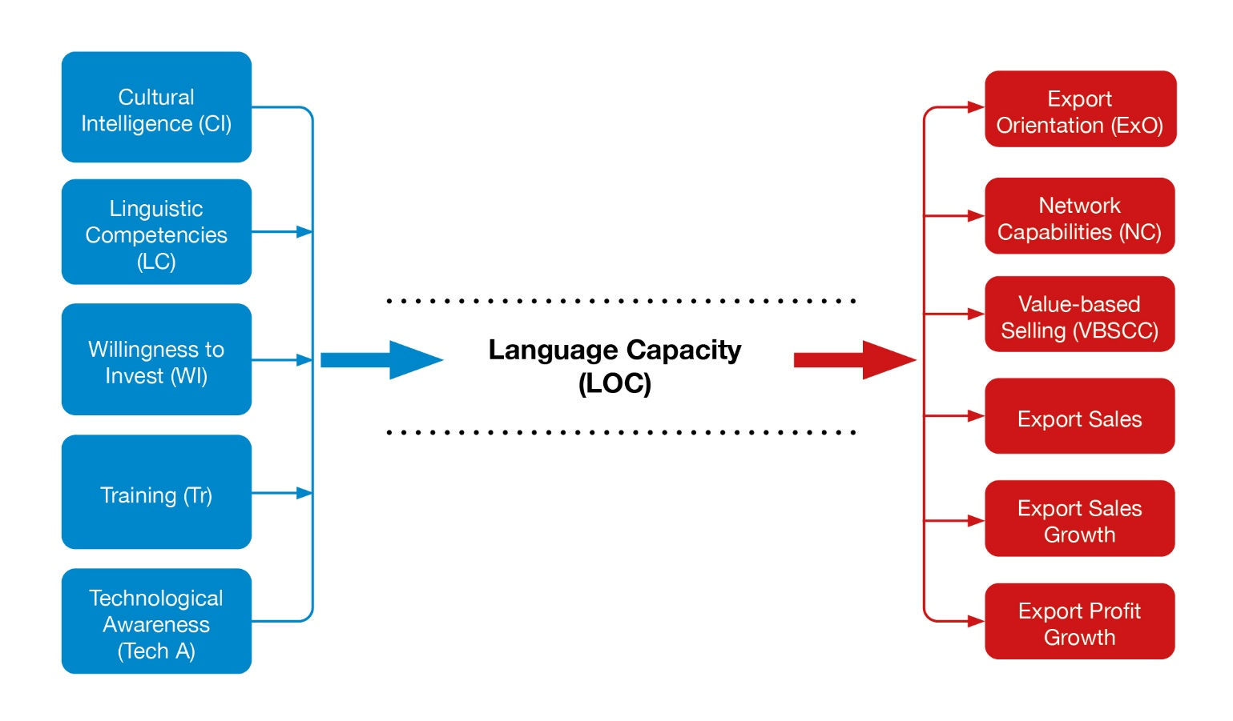
This diagram outlines the scope of the study, which identifies factors influencing language capacity; and how language capacity then impacts performance factors relevant to an SME seeking to internationalise.

Main Findings (1): Descriptive Statistics – Means, Standard Deviations and Correlations
Means – a type of average – and standard deviations – movement away from the average on either side – are the basis of any statistical analysis and we present here means and standard deviations of key factors studied in this report, namely, Linguistic Competencies (LC), Cultural Intelligence (CI), Willingness to Invest (WI), Training (Tr), Technological Awareness (TechA), Language Capacity (LO-C), Export Orientation (ExO), Networking Capability (NC) and Value-based Selling (VBSCC).

Means and standard deviations for our data
Descriptive Statistics
 | LO-C | NC | VBSCC | ExO | LC | CI | WI | Tr | TechA
N | 417 | 416 | 416 | 415 | 417 | 417 | 417 | 417 | 417
Mean | 3.6478 | 3.7668 | 3.9156 | 3.7774 | 3.6171 | 4.0600 | 3.6387 | 3.2206 | 4.1543
StandardDeviation | 0.78481 | 0.87711 | 0.68496 | 0.68257 | 1.11286 | 0.61144 | 0.95632 | 1.13125 | 0.63752
Skewness | -0.646 | -0.861 | -0.774 | -0.544 | -0.796 | -0.738 | -0.732 | -0.357 | -1.106
Kurtosis | 0.223 | 0.911 | 1.056 | 0.090 | -0.193 | 1.301 | 0.223 | -0.795 | 2.509
Table 1: Means and standard deviations

In summary, this means:
- The highest average score across the group was for Technological Awareness (defined as technology-facilitated language services, e.g. Google Translate). Training (defined as facilitating language training courses for staff development) had the lowest score. Therefore, of the factors considered, SMEs’ highest capability was in Technological Awareness. Training had the lowest level of capability.
- Training also had the largest variance in values between firms. This means for this characteristic there was the widest score between the highest and lowest of firms in the study. Technological Awareness had the lowest variance, so all firms performed at a similar level.

Correlations Analysis
The correlation coefficient indicates the strength of association between factors involved in the study. The value ranges from +1 to -1 indicating a perfect positive relationship (45-degree slope), 0 indicating no relationship (flat horizontal line) and -1 indicating a perfect negative or reverse relationship. We have no negative relationship factors in our study.
The key drivers within an organisation that facilitate the identification of LO-C are Linguistic Competencies, Cultural Intelligence, Willingness to Invest and Training for Languages and Technological Awareness. The drivers are corelated but at the same time distinct, which has been tested using validity measures and all correlations are statistically significant. Further, existing research identifies Export Orientation (ExO) as a key subjective measure for export performance. We also examined Networking Capability (NC) and Value-based Selling (VBSCC) as other important concepts related to business. Along with Export Orientation, which has been identified as a key indicator of exports among SMEs, Export Sales, Export Profit and Export Sales Growth are measured on a five- point Likert scale to study the impact of LO-C on actual performance indicators. Please refer to Table VII, VIII and IX for correlation coefficients in Appendix. A summary of correlation analysis is presented below:

- Linguistic Competencies is defined as the linguistic competencies of an individual and is highly correlated with cultural intelligence. SMEs that invest in individual language skills or employing staff with language skills are better able to understand cultural differences between markets and vice-versa.
- Less so but still significant, Linguistic Competencies is also correlated with Willingness to Invest (defined as investments in document translation for instance) and also in Training.
- Willingness to Invest is also highly correlated with Cultural Intelligence (adapting to new contexts, and training and slightly less so with Technological Awareness.
- Export Orientation is highly correlated with Value-based Selling in international markets. So, firms which are more export-oriented work closer with customers to develop products and create value in export markets.
- Still significant is Export Orientation and Networking Capability – so firms active internationally work hard to build networks.
- Value-based Selling and Networking Capability are highly correlated. This indicates how SMEs use networks to build value amongst groups of customers in export markets.
- Not unexpectedly, sales, growth and profits are highly correlated and, in that sense, confirm the underlying validity of the data.
- Also Export Orientation is correlated towards sales, profit and growth. This is important in our study because it highlights any factors which can influence Export Orientation will have a positive impact on the international sales, growth and profit prospects of an SME. In this study, LO-C is highly correlated with Export Orientation and is considered in more detail in the regression analysis.

Main Findings (2): Impact of LO-C on Performance Indicators
The multiple regression (linear) model (measured as Y= b₀ + b₁X₁ +b₂X₂ +…+ e), which measures the regression coefficients (b_{1,} b_{2.}), is a numerical value of predictor-x (independent) variable on predicted-y (outcome) variable and has been utilised to estimate the impact of LO-C on both subjective and objective outcomes. It is important to mention that we have size, industry/sector, age of the firm (in years), exporting experience and number of countries exported to as control variables.

Key Performance Indicators
Using the SPSS statistical tool, the following graphs represent regression coefficients (b) of LO-C; for Export Orientation (ExO), the value is 0.594, while for Export Sales it is 0.296, for Export Profit it is 0.346, and for Export sales Growth it is 0.328 (refer to Appendix– Table X, Table XIII, Table XIV, and Table XV). Regression coefficient represents the amount of change in the outcome (predicted) variable for a one-unit change in independent (predictor) variable.

Below is a graphical presentation of the impact of LO-C on key performance indicators:
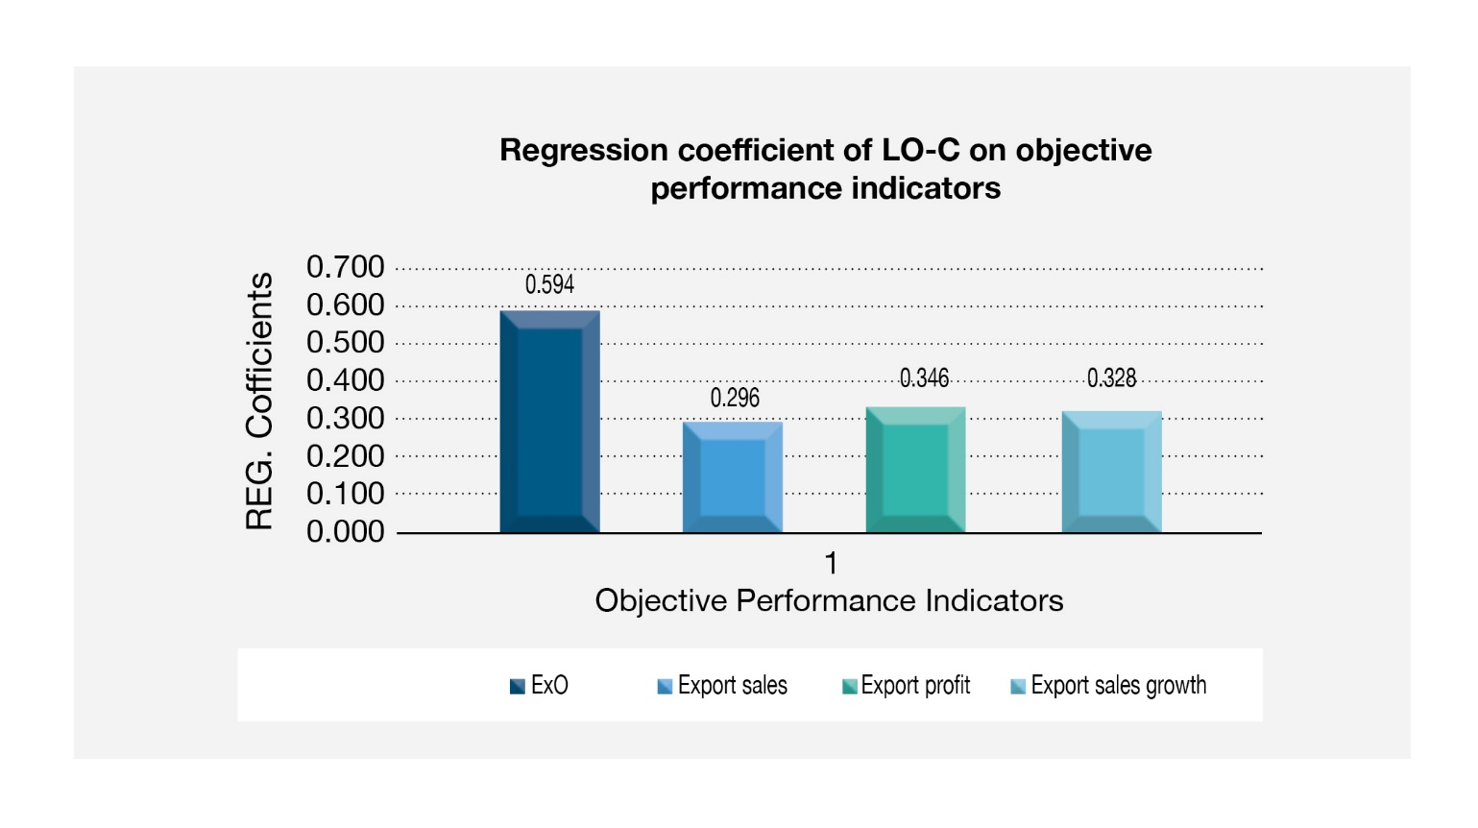
Figure 6: Regression coefficients of LO-C on key performance indicators

The focus of the research is language capability at an organisational level and its impact on Export Orientation, Export Sales, Export Profit and Export Sales Growth. Obviously, there are other factors, e.g. cost of production and marketing expenditure, which were not considered in this study. We wanted to look at how language could assist exporters. These results show:

- LO-C has statistically a very strong relationship with Export Orientation. Firms which are motivated and plan and use languages are highly likely to increase Export Orientation.
Indeed, every one-unit increase in LO-C investment produces a 0.594 increase in the firm’s export orientation. This means the more the firm invests in languages and related factors, the greater the increase there will be in Export Orientation.
- We know the strength of relationship proven earlier between Export Orientation and Export Sales, Export Sales Growth and Export Profit. LO-C has a significant indirect impact on all these indicators.
- LO-C also has a significant direct relationship on Export Sales, Export Growth and Export Profit and every one-unit increase in LOC investment also produces increased Export Profit (0.346), Export Sales (0.296) and Export Sales Growth (0.328).
- As we see the sector coefficients financial services, retail, automotive and IT services are all statistically insignificant, this indicates that impact of LO-C on the performance indicators does not vary in comparison to the manufacturing sector as a base sector in our sample. The direct relationship between LO-C and Export Sales, Export Sales Growth and Export Profit is therefore sector agnostic in our study – that is, impact is not significantly different for different sectors.

Subjective Performance Indicators
Using the SPSS statistical tool, the following graphs represent regression coefficients of LO-C; for Networking Capability (NC), the value is 0.642 and for Value-based Selling (VBSCC) it is 0.585. The regression coefficient represents the amount of change in the outcome (predicted) variable for a one-unit change in independent (predictor) variable.

Below is the graph of coefficients of regression models:

Figure 7: Regression coefficient of LO-C on subjective performance indicators

These results show a very strong relationship between LO-C and Value-based Selling (VBSCC) and Networking Capability (NC). This means:

- We noted earlier that Export Orientation was highly correlated with Value-based Selling and networking in international markets. LO-C also has a strong relationship with these factors. Indeed, every one-unit increase in LO-C investment produces a 0.585 increase in Value-based Selling and a 0.642 increase in Networking Capability. LO-C therefore also has an indirect relationship with Export Orientation due to its high correlation with Value-based Selling and Networking Capability in international markets.

Main Findings (3): Key Drivers of LO-C
Using the SPSS statistical tool, the following graphs represent standardised beta coefficients (b) of Linguistic Competencies (0.210), Cultural Intelligence (0.227), Willingness to Invest (0.275), Training (0.349) and Technological Awareness (0.065) on language capacity (LO-C). These regression coefficients indicate the relative importance of each driver on language capacity (LO-C).

Regression coefficients of LO-C are presented in graph form below:

Figure 8: Standard coefficient of key drivers on LO-C

In our sample this means:
- Training and Willing to Invest are the top two factors influencing LO-C. Increases in training and staff development in languages together with readiness to invest in translation of relevant documents, packaging, marketing material, etc will have the most significant impact on LO-C. This will strengthen the role that Linguistic Competencies play within SMEs.

- Technological Awareness is the least important driver to LO-C. More importantly, Linguistic Competencies and Cultural Intelligence are both critical for adept LO-C within the organisation.

Conclusion

Our research is to our knowledge the first large-scale quantitative study focusing on language capacity at an organisation level and its impact on Export Orientation, Export Sales, Export Profit and Export Sales Growth. Obviously, there are other factors that will influence the success of trading globally (cost of production, marketing expenditure, etc) which are not considered in this study. Our objective has been to focus on language capacity (LO-C) at an organisation level as defined as attitudes and behaviour, as well as shared perception of policies and practice of employees and the management alike towards the role that linguistic competencies play within the organisation for international business and marketing. The study sought to identify how LO-C can impact SMEs’ international trading performance. Our research has proven linguistic competencies is highly corelated with a cultural intelligence in export markets and willingness to invest and training will support this. LO-C has statistically a very strong relationship with Export Orientation, which in turn is highly correlated with Export Sales, Export Profit and Export Sales Growth. So, SMEs which are motivated and plan and use languages are highly likely to increase Export Orientation, and this research clearly indicates SMEs embracing language capabilities are 30% more successful in exporting than those which do not. LO-C has a consequential positive impact on Export Orientation, Export Sales, Export Growth and Export Profit. LO-C also has a strong relationship with Value-based Selling and Networking Capability, which again are highly correlated with Export Orientation. Furthermore, SMEs with successful international performance utilise language capacity not only through linguistic competence and cultural awareness but also by engaging in language training and/or having a willingness to invest (in language services, for instance) to build global networks.

Support for Business

Aston Business School is committed to partnering with industry to share research findings that enable us to learn about practical issues facing organisations today. Our view is that through forming partnerships with industry, our research has practical relevance and addresses pressing issues faced by organisations and/or industry in today’s ever-increasingly competitive and global markets.

If you would like to be updated about seminars, workshops, events and information regarding critical issues like internationalisation and entrepreneurship, please email: tibrewaa@aston.ac.uk.
Or, for more information concerning the range of services and support Aston Business School can provide to your business, please visit: https://www2.aston.ac.uk/aston-business-school.

Glossary of Terms

Key Variables in Model
  - Exporting activities: Exporting includes exporting directly by the firm, selling to foreign and LO-C representatives or offices, and through a sales agent/office/branch in foreign markets.
  - Language capacity (LO-C): LO-C refers to both motivation and preparedness (attitude) towards developing language-related capabilities as well as (behaviour) actual utilisation of the language capabilities within the organisation.
  - Linguistic Competencies (LC): LC refers to different levels of language competencies defined by CEBR and is identified as linguistic competencies of an individual.
  - Cultural Intelligence (CI): This is defined as a person’s capability to adapt effectively to new cultural contexts.
  - Technological Awareness (TA): Awareness of technology-facilitated services in languages such as translation companies or computer-assisted (machine learning) services like Google Translate, WeChat or any similar platforms or services.
  - Willingness to Invest (WI): Readiness to invest in translation of relevant documents for e.g. operation manuals, website translation, packaging, etc.
  - Training (Tr): Encourage, support and facilitate staff development through language training courses online or otherwise.
  - Export Orientation (ExO): Export orientation refers to a firm’s ability to generate, respond and disseminate export intelligence/information for enhancing exports.
  - Networking Capability (NC): Utilisation of personal and/or professional connections and networks with customers, suppliers, competitors, etc.
  - Value-based Selling and Co-creation in International Markets (VBSCC): Understanding customers’ requirements, creating/adapting products and services by collaborating with buyers.

Statistical Tools
  - Regression analysis: The multiple regression (linear) model is measured as Y= b₀ + b₁X₁ +b₂X₂ +…+ e and measures the regression coefficients (b_{1,} b_{2.}) as a numerical value of predictor-x (independent) variable on predicted-y (outcome) variable.
  - Regression coefficient (b): This represents the amount of change in the outcome (predicted) variable for a one-unit change in independent (predictor) variable. Multiple regression analysis estimates regression coefficients which indicate the relative importance of each independent (predictor) variable on predicted (outcome) variable.
  - Coefficient of determination (adjusted R²): This measures explanatory power of the model and provides an estimate of strength of relationship between the variables in the model and is not the formal statistical test for the relationship. F-test of overall significance determines whether the relationship is significant or not.
  - Exploratory factor analysis (EFA) and confirmatory factor analysis (CFA): EFA is a statistical method to identify the underlying structure of a large set of variables and CFA is then used to validate the results and assess the replicability of results in the analysis.

Control Variables
- Size: Number of employees
- Age-:Number of years since inception
- Industry/sector
- Exporting years: Number of years firm has been exporting.
- Number of countries exported to

Appendix
Appendix to LO-C 30 Report shared on Google Drive

LO-C refers to motivation as well utilisation of language capabilities within the organisation. Refer to Glossary of Terms.
Please refer to Glossary of Terms.
Please refer to Glossary of Terms.
Please refer to Glossary of Terms.
Coefficient of determination (adjusted R²) which measures explanatory power of the model is 0.461 for Export Orientation and 0.475 for Value-based Selling.
Coefficient of determination (adjusted R²) is 0.114, 0.126 and 0.119 for Export Sales, Export Profit and Export Sales Growth respectively.
7Coefficient of determination (adjusted R2) which measures explanatory power of the model is 0.787 (ranges between 0 and 1). For definition, refer to Glossary of Terms.
‘University of the Year’, 2020 and Outstanding Entrepreneurial University, 2020 by The Guardian and Times Higher Education Awards respectively.
Please refer to Glossary of Terms.
Please refer to Glossary of Terms.
Please refer Glossary of Terms.
Coefficient of determination (adjusted R²) which measures explanatory power of the model; Export Orientation model is 0.474, Export Sales model is 0.114, Export Profit model is 0.126 and Export Sales Growth model is 0.119 (R² ranges between 0 and 1). It is important to note that adjusted R² provides an estimate of strength of relationship between the variables in the model and is not the formal statistical test for the relationship. F-test of overall significance determines whether the relationship is significant.
Coefficient of determination (adjusted R²) which measures explanatory power of Networking Capability model (Table XI) is 0.356 and Value-based Selling model (Table XII) is 0.488. (Adjusted R² ranges between 0 and 1.)
It is important to note that adjusted R² which measures explanatory power of the model is 0.787 (ranges between 0 and 1).

